Code of Conduct

Code of conduct is a set of rules every member in the group must follow.

**Rules:**

* Be present
* Don’t be late
  + A strike will be issued without a proper reason.
* Finish tasks
  + A strike will be issued if the work is not completed or not in our standards.
* Announce in time if you’ll be absent
  + A strike will be issued if not announced.
* Keep track of the group chat
* Active participation
* Don’t overuse AI tools
  + A strike will be issued if AI tools such as ChatGPT are used more than 20%.
* Speak English
* Let everyone speak.
* Don’t criticize.
* Don’t speak on top of another one
* Don’t argue
* Give feedback and opinions
* Ask for help if needed
  + A strike will be issued if any of the social rules are broken.

**Warning:**

Warning are intended to inform members of IT1C about situations that may need attention or could lead to undesired outcomes.

* If a member of IT1C has at 4 strikes the consequences are the following:
  + The member will be sent to a meeting with the team and decide weather he/she will receive a warning.
  + If someone received a warning they will have a meeting with the mentor and he/she behavior will be improved.
  + If the behavior isn’t improved after the meeting, they will receive a second warning.



**Members:**



Each member have their own roles and fulfill their roles on their description

* Team leader: Diego D.
* Client communicator: Leon T.
* Secretary: Erika N.
* Resource investigator: Bill D.
* Completer finisher: Mihaela C.
* Implementer: Mihael D.

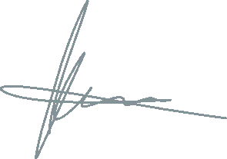

* Facility manager: Artem S.

Roles can be changed according to the necessity.



**Schedule:**

2 days a week in contact

1 day with Miguel

